**ME 497 / 498 BİTİRME PROJESİ I / II ŞABLONU AÇIKLAMA FORMU**

**ME 497 / 498 SENIOR DESIGN PROJECT I / II TEMPLATE EXPLANATION FORM.**

**.**

|  |  |  |  |
| --- | --- | --- | --- |
| 1. Şablonda belirtilen boşluklar ve yerleşim düzeni sabit kalmalıdır. |  |  | 1. Spacing and placement in the template must not be changed. |
| 1. Jüri tarihi Başlık Sayfası, İmza Sayfası, Abstract ve Özet’de ilgili yerlere yazılmalıdır. |  |  | 1. Write defense date to the related places given on Title page, Approval page, Abstract and Öz. |
| 1. Özet 250-350 kelimeden oluşmalıdır. |  |  | 1. Abstract should include 250-350 words. |
| 1. Proje raporunun son sayfasının sayfa numarası Abstract ve Özet’de ilgili yerlere yazılmalıdır. |  |  | 1. Write the page number of the last page of the project report in the related places given on Abstract and Özet pages. |
| 1. Bütün bölümler, referanslar, ekler ve CV sağ sayfada başlamalıdır. Bunun için **kesmeler** kullanılmıştır. **Kesmelerin kayması** fazladan boş sayfaların oluşmasına sebep olabilir. Bu gibi durumlarda paragraf (¶) işaretine tıklayarak kesmeleri görünür hale getirin ve yerlerini **kontrol edin**. |  |  | 1. All chapters, references, appendices and CV must be started on theright page. **Section Breaks** were used for this. **Change in the placement** of section breaks can result in extra blank pages. In such cases, make the section breaks visible by clicking paragraph (¶) mark and **check their position.** |
| 1. Figürler ve tablolar kenar boşluklarına taşmamalıdır. |  |  | 1. All figures and tables must be given inside the page. Nothing must appear in the margins. |
| 1. Şablonda yorum olarak eklenen uyarılar dikkatle okunmalı ve uygulanmalıdır. |  |  | 1. All the warnings given on the comments section through the project template must be read and applied. |
| 1. Proje yazdırılmadan önce PDF olarak kaydedilmelidir. Şablonda yorum olarak eklenen uyarılar PDF dokümanında yer almamalıdır. |  |  | 1. Save your project as pdf and Disable all the comments before taking the printout. |
| 1. **Bu form aracılığıyla oluşturulan PDF dosyası arkalı-önlü baskı alınarak tek bir spiralli haline getirilmelidir.** |  |  | 1. **Print two-sided the PDF file that you have created through this form and make a single spiral bound.** |
| 1. Spiralli hale getirilen proje taslağınızdaki ilgili alanları imzalandıktan sonra, proje danışmanınıza teslim edilmelidir. |  |  | 1. Once you have signed the relevant fields in your project draft that you spiraled, submit it to your project supervisor. |

|  |  |  |  |  |  |
| --- | --- | --- | --- | --- | --- |
|  | **Yukarıda bulunan tüm maddeleri okudum, anladım ve kabul ediyorum. / I have read, understand and accept all of the items above.**  **Name :**  **Surname :**  **E-Mail :**  **Date :**  **Signature : ________________________** | | | | |
|  | |  |  |  |  |



**PROJECT TITLE**

**ME 497 / 498 SENIOR DESIGN PROJECT I / II REPORT**

**BY**

**NAME SURNAME**

UNIVERSITY OF TURKISH AERONAUTICAL ASSOCIATION

DEPARTMENT OF MECHANICAL ENGINEERING

**SUPERVISED BY**

**TITLE, NAME SURNAME**

January 2024

Approval of the project report:

**PROJECT TITLE**

submitted by **NAME SURNAME** in partial fulfillment of the requirements for the degree of Bachelor Science i**n** Mechanical Engineering**, University of Turkish Aeronautical Association** by,

|  |  |
| --- | --- |
| Asst. Prof. Dr. Name Surname  Supervisor, **Department of Mechanical Engineering, UTAA** |  |

Date: ...

**I hereby declare that all information in this document has been obtained and presented in accordance with academic rules and ethical conduct. I also declare that, as required by these rules and conduct, I have fully cited and referenced all material and results that are not original to this work.**

Name, Surname :

Signature :

ABSTRACT

**PROJECT TITLE**

Surname, Name

Bachelor Science, Mechanical Engineering

Supervisor : Asst. Prof. Dr. Name Surname

Co-Supervisor (if there is): Assoc. Prof. Dr. Name Surname

Presentation Date, # pages

Abstract should be between 250-350 words. Turkish Aeronautical Association aimed to become the center of production and training activities of aeronautical practices and went into action to transfer the years of intellectual knowledge to the academic basis in order to accomplish this goal. Activities to establish the University of Turkish Aeronautical Association were commenced in 2010. After conducting researches on other universities specialized in aeronautics in Turkey and around the world, a comprehensible feasibility report regarding the establishment of a “University of Aeronautics and Astronautics” was prepared. In line with this report, the relevant application about the establishment of the first and only university in Turkey “specialized in aeronautics and astronautics” was given to the Higher Education Board on September 3rd, 2010. The Department of Mechanical Engineering started education by admitting its first students in the 2012-2013 academic year.

Keywords: Project Writing, Project Format (Max. 5 keywords)

ÖZET

**PROJE BAŞLIĞI**

Soyadı, Adı

Lisans, Makine Mühendisliği

Proje Yöneticisi: Dr. Öğr. Üyesi Adı Soyadı

Ortak Proje Yöneticisi (varsa): Doç. Dr. Adı Soyadı

Sunum Tarihi, # sayfa

Türk Hava Kurumu, havacılık ve uzay alanındaki üretim ve eğitim faaliyetlerinin merkezi olmayı hedeflemiş; bunu gerçekleştirebilmek için yılların birikimi olan entelektüel bilginin akademik bir zemine taşınması için çalışmalara başlamıştır. ‘Türk Hava Kurumu Üniversitesi’ni kurma çalışmaları 2010 yılı itibariyle başlamıştır. Türkiye ve Dünya’daki havacılık ile ilgili üniversiteler incelenerek “Havacılık ve Uzay Bilimleri Üniversitesi” kurulmasına yönelik kapsamlı bir fizibilite raporu hazırlanmıştır. Bu rapor doğrultusunda, Türkiye’nin ilk ve tek ”havacılık ve uzay bilimleri ihtisas üniversitesinin” kuruluş başvurusuyla ilgili dosya, 3 Eylül 2010 tarihinde YÖK Başkanlığına teslim edilmiştir. Makine Mühendisliği Bölümü 2012-2013 akademik yılında ilk öğrencilerini alarak eğitime başlamıştır.

Anahtar Kelimeler: ProjeYazımı, Proje Formatı (En fazla 5 anahtar kelime)

Dedication

ACKNOWLEDGMENTS

The author wishes to express his deepest gratitude to his supervisor Asst. Prof. Dr. Name Surname for his guidance, advice, criticism, encouragements and insight throughout the research.

The author would also like to thank Assoc. Prof. Dr. Name Surname, and Assoc. Prof. Dr. Name Surname for their suggestions and comments.

The technical assistance of Mr. Name Surname, Mr. Name Surname and Ms. Name Surname are gratefully acknowledged.

This work is partially funded by Scientific and Technological Research Council of Turkey under grant number TUBİTAK 2209b

TABLE OF CONTENTS

ABSTRACT v

ÖZET vii

ACKNOWLEDGMENTS x

TABLE OF CONTENTS xi

LIST OF TABLES xiii

LIST OF FIGURES xiv

LIST OF ABBREVIATIONS xv

LIST OF SYMBOLS xvi

1 INTRODUCTION 1

1.1 Motivation of the Project- Heading 2 1

1.2 Contributions 1

1.3 The Outline of the Project Report 3

2 LITERATURE REVIEW 5

2.1 Citing in the Text -(Heading 2) 5

2.1.1 Sample Table (Heading 3) 7

2.1.2 Formatting the Reference List (Heading 3) 7

3 MATERIAL AND METHOD 9

3.1 Citing in the Text -(Heading 2) 9

4 RESULTS AND CONCLUSION 9

REFERENCES 11

A.Appendix Title 13

B.Appendix Title 14

C.Appendix Title 15

CURRICULUM VITAE 18

LIST OF TABLES

TABLES

Table ‎2.1: Results 7

LIST OF FIGURES

FIGURES

Figure ‎1.1: Training planes technical supports 2

Figure ‎1.2: Computer aided design lab 2

Figure ‎2.1: UTAA modern airplanes 6

LIST OF ABBREVIATIONS

ABBREVIATIONS

Remove this page if it is not necessary

LIST OF SYMBOLS

SYMBOLS

Remove this page if it is not necessary

# 1. INTRODUCTION

In this section, introduce your project content. The number sub-sections can be increased or decreased. On the pages up to the “INTRODUCTION” section, page numbers should be shown in Roman numerals format (i, ii, iii, iv, v, vi, vii, viii, etc.).

## Motivation of the Project- Heading 2

Use Times New Roman 12 punto and 1.5 line spacing in your report. Paragraphs should be justified. The titles of the main sections should be 14 punto and must be written in capital letters. The titles of the sub-sections should be 12 punto and the initial letters of the words should be written in capital letters. The titles of sub-sections in this template are just sample, so they can be changed. The titles of main sections should not be changed. Figure captions should be centerized.

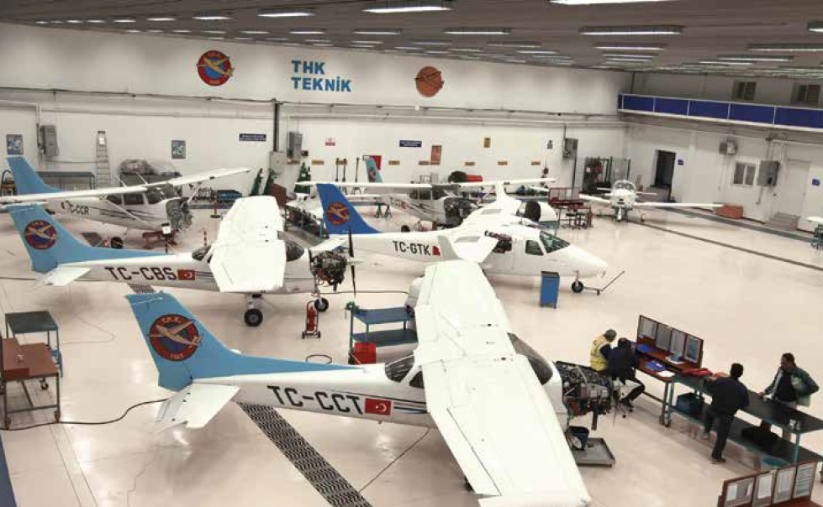

Figure ‎1.1: Training planes technical supports

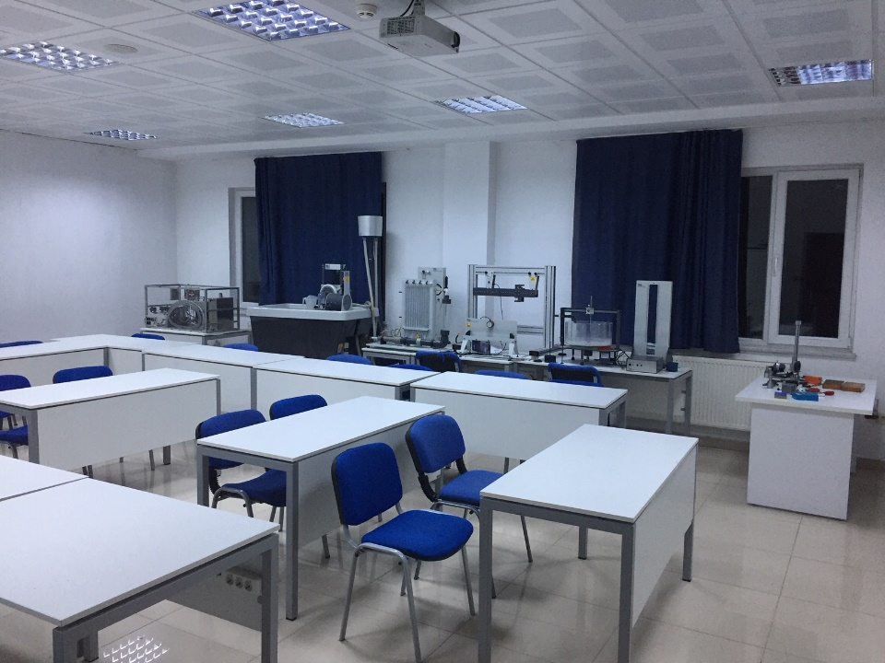

Figure ‎1.2: Mechanical engineering lab

## Contributions

Add your contributions:

* Contribution-1
* Contribution-2
* Contribution-3, etc.

## The Outline of the Project Report

Add the outline of your project report.

# 2. LITERATURE REVIEW

Use “IEEE Referencing Guide” in your report: [IEEE Reference Style Guide for Authors](https://journals.ieeeauthorcenter.ieee.org/wp-content/uploads/sites/7/IEEE_Reference_Guide.pdf).

## Citing in the Text

Indicating the relevant reference in the text: A number enclosed in square brackets, eg.[1] or [26], placed in the text of the essay, indicates the relevant reference. Each reference number should be enclosed in square brackets on the same line as the text, before any punctuation, with a space before the bracket. Citations are numbered in the order in which they appear in the text and each citation corresponds to a numbered reference containing publication information about the source cited in the reference list at the end of the publication, essay or assignment. Once a source has been cited, the same number is used in all subsequent references. No distinction is made between print and electronic references when citing within the text. Here are some examples of this kind of referencing :

"...end of the line for my research [13]."

"The theory was first put forward in 1987 [1]." "Scholtz [2] has argued that......."

"Several recent studies [3, 4, 15, 16] have suggested that..."

"For example, see [7]."

It is not necessary to mention either the author(s) or the the date of the reference unless it is relevant to your text. It is not necessary to say " in reference [26] ..." "In [26] ..." is sufficient.

Citing more than one reference at a time: When citing more than one source at a time, the preferred method is to list each reference number separately with a comma or dash between each reference.

Preferred:

[1], [3], [5]

[1] - [5]

Although the following method is also acceptable:

Acceptable:

[1, 3, 5]

[1-5]

Citing a reference multiple times: When citing a source for a second or subsequent time, do not use ibid or op. cit. In the text, repeat the earlier reference number. If referring to a different page number, or other reference, within the source, use the following forms: [3, pp. 5-10], [3, Ch. 2, pp. 6-21], [3, Fig. 1], [3, Sec. 4.5]

### Sample Table

Table .: Literature Data

|  |  |  |  |
| --- | --- | --- | --- |
| Country List | | | |
| Country Name or Area Name | ISO ALPHA 2 Code | ISO ALPHA 3 Code | ISO numeric Code |
| Afghanistan  Albania  Algeria  American Samoa  Andorra  Angola | AF  AL  DZ  AS  AD  AO | ALA  ALB  DZA  ASM  AND  AGO | 248  008  012  016  020  024 |

### Formatting the Reference List

The reference list should appear at the end of your paper. Begin the list on a new page. The title REFERENCES should be centered on the page.The hanging indent for each reference makes the numerical sequence more obvious. The entries should appear as one numerical sequence in the order that the material is cited in the text of your assignment.

# 3. MATERIAL AND METHOD

The Materials and Methods section briefly describes how you did your research. In other words, what did you do to answer your research question? If there were materials used for the research or materials experimented on you list them in this section. You also describe how you did the research or experiment. The key to a methodology is that another person must be able to replicate your research—follow the steps you take. For example if you used the internet to do a search it is not enough to say you “searched the internet.” A reader would need to know which search engine and what key words you used.

Open this section by describing the overall approach you took or the materials used. Then describe to the readers step-by-step the methods you used including any data analysis performed. See Fig. 3.5 below for an example of materials and methods section.

### 3.1 Sample Equation

$y_{k}=∅_{k}\left(X\right)+x_{k}$ (1.1)

$y_{k}=x_{k}*P_{k}$ (1.2)

Writing tips:

Do:

* Explain procedures, materials, and equipment used
* Provide enough detail for replication!

Example: “We used an x-ray fluorescence spectrometer to analyze major and trace elements in the mystery mineral samples.”

* Order events chronologically, perhaps with subheadings (Field work, Lab Analysis, Statistical Models)
* Use past tense (you did X, Y, Z)
* Quantify measurements

Don’t:

* Include results in the methods! It’s easy to make this mistake!
* List unnecessary details; i.e., if someone could look up how to operate an instrument, you do not need to explain how to use that instrument.

Example: “We turned on the machine and loaded in our samples, then calibrated the instrument and pushed the start button and waited one hour. . . .”.

# 4. RESULTS AND CONCLUSION

Turkish Aeronautical Association aimed to become the center of production and training activities of aeronautical practices and went into action to transfer the years of intellectual knowledge to the academic basis in order to accomplish this goal. Turkish Aeronautical Association aimed to become the center of production and training activities of aeronautical practices and went into action to transfer the years of intellectual knowledge to the academic basis in order to accomplish this goal. A different Turkey, which can manufacture and export aircrafts as it used to do as well as remaining at the forefront of space research, was imagined and thought to be accomplished via a university that meets the increasing demand for qualified manpower and consists of the resources needed to support Research and Development.

Turkish Aeronautical Association aimed to become the center of production and training activities of aeronautical practices and went into action to transfer the years of intellectual knowledge to the academic basis in order to accomplish this goal. A different Turkey, which can manufacture and export aircrafts as it used to do as well as remaining at the forefront of space research, was imagined and thought to be accomplished via a university that meets the increasing demand for qualified manpower and consists of the resources needed to support Research and Development.

REFERENCES

Use “IEEE Referencing Guide” in end-text citation: [IEEE Reference Style Guide for Authors](https://journals.ieeeauthorcenter.ieee.org/wp-content/uploads/sites/7/IEEE_Reference_Guide.pdf).

The reference list should appear at the end of your paper. Begin the list on a new page. The title REFERENCES should be centered on the page.The hanging indent for each reference makes the numerical sequence more obvious. The entries should appear as one numerical sequence in the order that the material is cited in the text of your assignment.

Examples:

[1] A. Rezi and M. Allam, "Techniques in array processing by means of transformations, " in Control and Dynamic Systems, Vol. 69, Multidemsional Systems, C. T. Leondes, Ed. San Diego: Academic Press, 1995, pp. 133-180.

[2] G. O. Young, "Synthetic structure of industrial plastics," in Plastics, 2nd ed., vol. 3, J. Peters, Ed. New York: McGraw-Hill, 1964, pp. 15-64.

[3] M. M. Chiampi and L. L. Zilberti, “Induction of electric field in human bodies moving near MRI: An efficient BEM computational procedure,” IEEE Trans. Biomed. Eng., vol. 58, pp. 2787–2793, Oct. 2011, doi: 10.1109/TBME.2011.2158315.

[4] N. Osifchin and G. Vau, "Power considerations for the modernization of telecommunications in Central and Eastern European and former Soviet Union (CEE/FSU) countries," in Second Int. Telecommunications Energy Special Conf., 1997, pp. 9-16.

[5] D. Sarunyagate, Ed., Lasers. New York: McGraw-Hill, 1996.

[6] O. B. R. Strimpel, "Computer graphics," in McGraw-Hill Encyclopedia of Science and Technology, 8th ed., Vol. 4. New York: McGraw-Hill, 1997, pp. 279-283.

[7] K. Schwalbe, Information Technology Project Management, 3rd ed. Boston: Course Technology, 2004.

[8] M. N. DeMers, Fundamentals of Geographic Information Systems, 3rd ed. New York: John Wiley, 2005.

[9] L. Vertelney, M. Arent, and H. Lieberman, "Two disciplines in search of an interface: Reflections on a design problem," in The Art of Human-Computer Interface Design, B. Laurel, Ed. Reading, MA: Addison-Wesley, 1990. Reprinted in Human-Computer Interaction (ICT 235) Readings and Lecture Notes, Vol. 1. Murdoch: Murdoch Univ., 2005, pp. 32-37.

[10] E. P. Wigner, "Theory of traveling wave optical laser," Physical Review, vol.134, pp. A635-A646, Dec. 1965.

[11] J. U. Duncombe, "Infrared navigation - Part I: An assessment of feasibility," IEEE Transactions on Electron Devices, vol. ED-11, pp. 34-39, Jan. 1959.

[12] M. Bell, et al., Universities Online: A survey of online education and services in Australia, Occasional Paper Series 02-A. Canberra: Department of Education, Science and Training, 2002.

[13] T. J. van Weert and R. K. Munro, Eds., Informatics and the Digital Society: Social, ethical and cognitive issues: IFIP TC3/WG3.1&3.2 Open Conference on Social, Ethical and Cognitive Issues of Informatics and ICT, July 22-26, 2002, Dortmund, Germany. Boston: Kluwer Academic, 2003.

[14] I. S. Qamber, "Flow graph development method," Microelectronics Reliability, vol. 33, no. 9, pp. 1387-1395, Dec. 1993.

[15] Australia. Attorney-Generals Department. Digital Agenda Review, 4 Vols. Canberra: Attorney- General's Department, 2003.

[16] C. Rogers, Writer and Director, Grrls in IT. [Videorecording]. Bendigo, Vic.: Video Education Australasia, 1999.

[17] L. Bass, P. Clements, and R. Kazman. Software Architecture in Practice, 2nd ed. Reading, MA: Addison Wesley, 2003. [Online] Available: Safari e-book.

[18] D. Ince, "Acoustic coupler," in A Dictionary of the Internet. Oxford: Oxford University Press, 2001. [Online]. Available: Oxford Reference Online, http://www.oxfordreference.com. [Accessed: May 24, 2005].

[19] H. K. Edwards and V. Sridhar, "Analysis of software requirements engineering exercises in a global virtual team setup," Journal of Global Information Management, vol. 13, no. 2, p. 21+, April-June 2005. [Online]. Available: Academic OneFile, http://find.galegroup.com. [Accessed May 31, 2005].

[20] P. H. C. Eilers and J. J. Goeman, "Enhancing scatterplots with smoothed densities," Bioinformatics, vol. 20, no. 5, pp. 623-628, March 2004. [Online]. Available: www.oxfordjournals.org. [Accessed Sept. 18, 2004].

[21] A. Holub, "Is software engineering an oxymoron?" Software Development Times, p. 28+, March 2005. [Online]. Available: ProQuest, http://il.proquest.com. [Accessed May 23, 2005].

[22] H. Zhang, "Delay-insensitive networks," M.S. thesis, University of Waterloo, Waterloo, ON, Canada, 1997.

[23] “AlphaCom Communications introduces VMSK technology,” The Business Journal Online, May, 2000. [Online]. Available: http://www.business-journal.com/LateMay00/Alpha.html. [Accessed: May 2, 2000].

[24] J. Riley, "Call for new look at skilled migrants," The Australian, p. 35, May 31, 2005. Available: Factiva, http://global.factiva.com. [Accessed May 31, 2005].

[25] European Telecommunications Standards Institute, “Digital Video Broadcasting (DVB): Implementation guidelines for DVB terrestrial services; transmission aspects,” European Telecommunications Standards Institute, ETSI TR-101-190, 1997. [Online]. Available: http://www.etsi.org. [Accessed: Aug. 17, 1998].

[26] J. Geralds, "Sega Ends Production of Dreamcast," vnunet.com, para. 2, Jan. 31, 2001. [Online]. Available: http://nl1.vnunet.com/news/1116995. [Accessed Sept. 12, 2004].

[27] W. D. Scott & Co, Information Technology in Australia: Capacities and opportunities: A report to the Department of Science and Technology. [Microform]. W. D. Scott & Company Pty. Ltd. in association with Arthur D. Little Inc. Canberra: Department of Science and Technology, 1984.

[28] “A ‘layman’s’ explanation of Ultra Narrow Band technology,” Oct. 3, 2003. [Online]. Available: http://www.vmsk.org/Layman.pdf. [Accessed: Dec. 3, 2003].

**APPENDICES**

1. Appendix Title

Add appendix here

1. Appendix Title

Add appendix here

1. Appendix Title

Add appendix here

CURRICULUM VITAE

**PERSONAL INFORMATION**

Surname, Name: Faruk, Tülay

Nationality: Turkish (TC)

Date and Place of Birth: 1 April 1976, Ankara

Phone: +90 444 84 58

email: eng@thk.edu.tr

**EDUCATION**

|  |  |  |
| --- | --- | --- |
| **Degree** | **Institution** | **Year** |
| BS | UTAA Mechanical Engineering | 2019-20.. |
| High School | Atatürk Anadolu High School, Ankara | 2015-2019 |

**WORK EXPERIENCE**

|  |  |  |
| --- | --- | --- |
| **Year** | **Place** | **Enrollment** |
| 2023-Present | KLAN Mühendislik | Candidate Engineer |
| 2023 July | FMC Nurol | Intern Eng. Student |
| 2022 August | Arçelik | Intern Eng. Student |

**FOREIGN LANGUAGES**

Advanced English, Fluent German

**QUALIFICATIONS**

1. ALES:
2. TOEFL:
3. CATIA:
4. ANSYS:
5. etc